Haughley in Bloom

Haughley Green, Haughley New Street and Haughley Village.

A report for Parishioners, May 2023
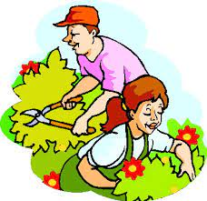

The hard-working team of volunteers who manage and sustain the Haughley in Bloom initiative continue to enhance the parish environment for parishioners and visitors alike and they thank all the kind parishioners who participated and helped them over the past year.

In 2022, the untended bed behind the coal-shed was removed and the bed on Folly Green taken over by the Bio-diversity team for inclusion in their planting trial. Other containers were inspected and treated to keep them looking good. We received many positive comments following installation of new rectangular planters on the Green and in 2023, as part of on-going maintenance work, the 4 old tubs on Old Street’s elevated grass verge will be replaced with modern containers. The 2022 planting scheme was well received and long-lasting in all well-tended Haughley in Bloom containers.

As usual the biggest challenge was to encourage more parishioners to support the team by helping to tend and water containers. Unsustainable containers will be excluded from the 2023 Haughley in Bloom display and removed to prevent them becoming an eyesore. More recently another issue has given the team cause for concern: increased traffic movements into and out of the parish and some very careless drivers: Grass verges and containers have been damaged and the team are considering what options might be open to them.

To end on a positive note: planning for the 2023 display is advancing well and planting will begin when our selected plants are ready and available from Woolpit Nursery.

Councillor Yvonne Hannan
Lead for the Haughley in Bloom Working Group

